**Prof. K. K. Verma**

**Head**

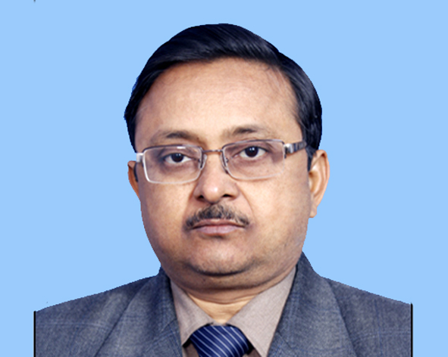

**Teaching and Research Experience:**

~ 23 years of teaching and research experience.

**Research Interest:**

* Experimental Material Science
* Thin Film HTSC
* Humidity sensor
* Microstrip Antenna Simulation
* Polymer Nanocomposite

**Recent Interest:**

* VLSI designing
* Electronic Circuit Simulation

**Distinguished and Notable Awards:**

* **SRF(CSIR)** Department of Physics, Banaras Hindu University,1991-1993
* **RA(DST),** Department of Physics, Banaras Hindu University,1993-1994
* **RA(CSIR),** Department of Physics, Banaras Hindu University,
* **Session co-chairman (in 1994)**-3rdNational Conference on Nanomaterials and Nanotechnology, Amity university, Lucknow, Nov-Dec, 2010.
* **Ph.D. research supervisor**, Career Point University, Kota.
* **Invited Lecture (DST-inspire)** Communication and its techniques BBS College of Engineering Allahabad – 2014.
* **Life Member Vigyan Parishad**, Allahabad
* **Life Member Materials research Society of India**, Bangalore.
* **Life Member Semiconductor Society of India**, New Delhi.
* **Life fellow “Antenna Test and Measurement Society”**.
* Member, Editorial Board, International Journal of scientific and Innovative research, India.
* Member, Editorial Board, ISST Journal of Applied Physics,India.

**Work Experience:**

* **Head**, Department of Physics and Electronics (17 .07.2017 to till to date).
* **Convener, Board of Studies (BOS),** Department of Physics and Electronics,17.07.2017 to till to date.
* **Coordinator, B.Sc. Programme**,17.08.2019 till to date.
* **Coordinator, MCJ**, 27.04.2018 to 16.09.2019.
* **Media Incharge**, 27.04.2018 to 16.09.2019.
* **Coordinator, RUSA and UGC Cell**, 29.03.2017-2018.
* **Incharge, Guest House**, 25.11.2017 to till to date.
* **Professor**, Department of Physics and Electronics, Dr. Rammanohar Lohia Avadh University, Ayodhya (01.06.2010 to till to date).
* **Associate Professor**, Department of Physics and Electronics, Dr.Rammanohar Lohia Avadh University, Ayodhya (24.12.2006 to31.05.2010).
* **Reader**, Department of Physics and Electronics, Dr. Rammanohar Lohia Avadh University, Ayodhya (24.12.2003 to 23.12.2006).
* **Lecturer**, Department of Physics and Electronics, Dr. Rammanohar Lohia Avadh University, Ayodhya (24.12.1994 to 23.12.2003).

**Citation/ h / i-10 Indexes:**

**Citation Index: 14**

**h-index: 2**

**i10-index: 0**

**No. of research papers in journals: 30**

**No. of research papers in Conference:**

1. **International: 21**
2. **National: 10**

**Participation in Conference/Seminars:31**

**No. of Books Edited/Published: 1**

**No. of Produced Ph.D.: 04**